PRODUCTION COMPANY INSIGHT-UKRAINE

Commercial offer

INSIGHR Production Company (Ukraine. City- Chernihiv). It offers certified products of European quality, and is also the only representative of two European brands, which allows you to comprehensively provide employees and a company of management and working personnel with special clothes and hats of high quality. High quality is the key to success, our partners
We are one of the three largest suppliers in the field of working clothes, shoes and seeds in Ukraine. More than 100 of our employees work hard to ensure that work with you is fast, high-quality and comfortable.
We are also ready for any innovations and design solutions, up to the branding of clothes under your brand or trademark

Why more than 3,000 customers have been choosing us for 10 years:

- The company has its own garment factory of 350 m2, which produces certified suits of two of its own brands Spetsnaz and FreeWork with the production of 3000 units per month.
2.
Own warehouse of 1500 m.sq., which allows you to maintain the availability of 200 thousand units of goods. So that our partner receives products under the contract/

Applying a logo thermo allows us to:
- use only high quality German materials for logos,
- branding
- Development of branding according to individual sizes and color scheme –brand

Our company has successfully implemented management tools that allow us to develop, and employees to constantly learn and improve their skills.
We have our own quality department that monitors
Control of products at all stages of production,

We also develop 3-4 new models; find innovative solutions in production for the innovation of products in design

Your own testing laboratory allows you to shoot the best video materials for the operation of our product. You can get acquainted with them on our channel YouTube.
https://www.youtube.com/c/%D0%9A%D0%BE%D0%BC%D0%BF%D0%B0%D0%BD%D0%B8%D1%8F%D0%98%D0%9D%D0%A1%D0%90%D0%99%D0%A2
https://www.facebook.com/zpeznaz/

3.
INSIGHT is always pleased with new partners.
If your company takes care of its employees, you will definitely like our products,
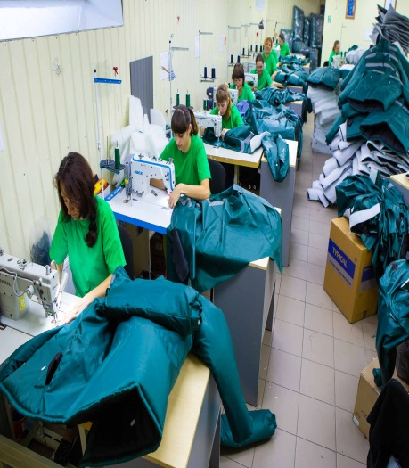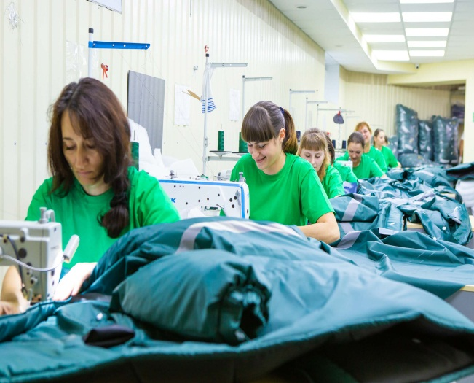

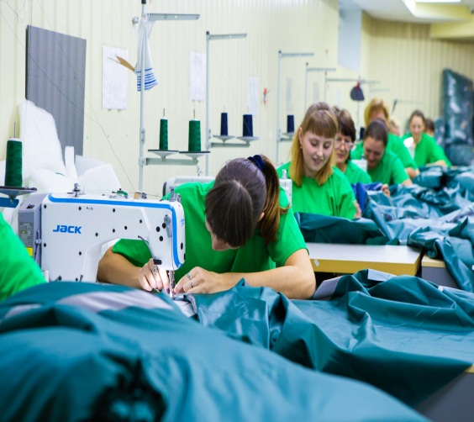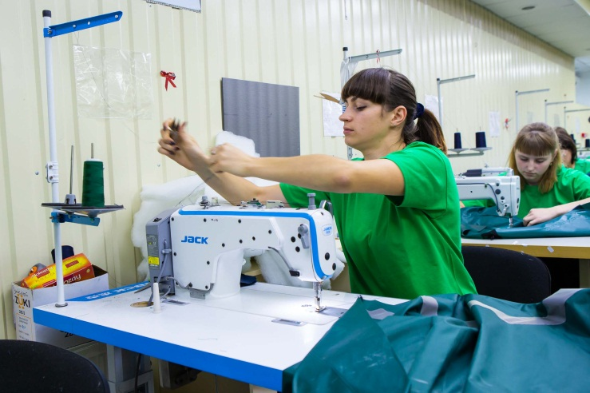

Our: specnaz.ua ( UKRAINE)

