It has been prepared in accordance with the Regulation (EC) No 1272/2008
1. IDENTIFICATION OF THE MATERIAL/PREPARATION AND COMPANY/OWNER
1.1.Product Identifier
Material/Preparation Name and Code: Yalaz Acrylic Paint
Preparation Date: 01/09/2008
MSDS Code:CXQ 11003
HS Code:3208.90.91.00.29

1.2 Relevant identified uses of the substance or mixture and uses advised against.
Use of the Material / Preparation:Acrylic resin based top-coat car refinishing paint.

1.3. Details of the supplier of the safety data sheet
Supplier: Yalaz Boya Kim.Ve Gida Ürn.İth.İhr.San.Tic.Ltd.Şti
Yazıbaşı Torbalı İZMİR
www.yalazboya.com.tr
e-mail address of person responsible for this SDS :sedayalaz@yalazboya.com.tr
1.4.Emergency Phone: 02324792635

2. HAZARDS IDENTIFICATION

2.1. Classification of the substance or mixture
Classification (EC 1272/2008)

Physical hazards:Flam. Liq. 2 - H225

Health hazards:Skin Irrit. 2 - H315 Repr. 2 - H361d STOT RE 2 - H373 Asp. Tox. 1 - H304

Environmental hazards:Not Classified

2.2. Label elements
Pictogram

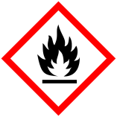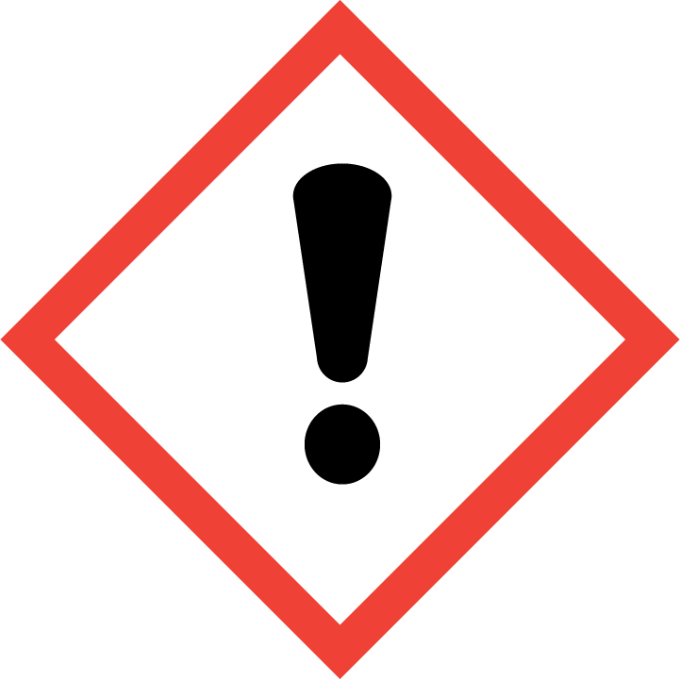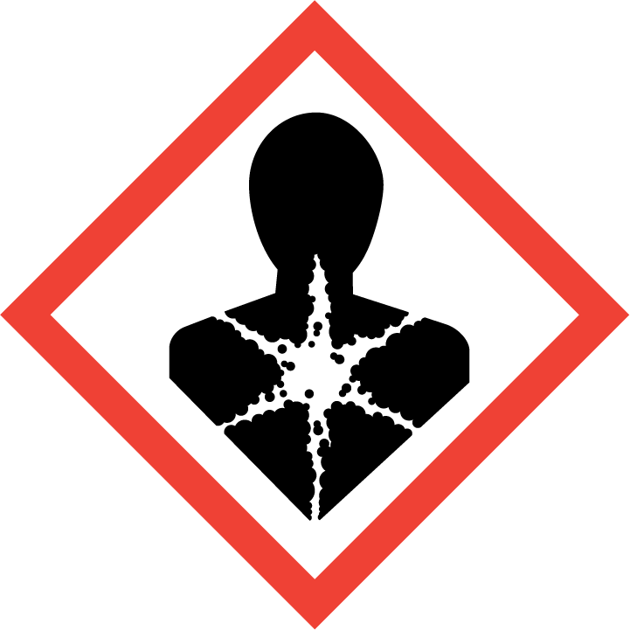

Signal Word :Danger

Hazar Statements:

H225 Highly flammable liquid and vapour.
H304 May be fatal if swallowed and enters airways.
H315 Causes skin irritation.
H361d Suspected of damaging the unborn child.
H373 May cause damage to organs through prolonged or repeated exposure.

Precautionary statements:

P201 Obtain special instructions before use.
P202 Do not handle until all safety precautions have been read and understood.
P210 Keep away from heat, hot surfaces, sparks, open flames and other ignition sources. No
smoking.
P233 Keep container tightly closed.
P240 Ground/ bond container and receiving equipment.
P241 Use explosion-proof electrical equipment.
P242 Use only non-sparking tools.
P243 Take precautionary measures against static discharge.
P260 Do not breathe vapour/ spray.
P264 Wash contaminated skin thoroughly after handling.
P280 Wear protective gloves/ protective clothing/ eye protection/ face protection.
P301+P310 IF SWALLOWED: Immediately call a POISON CENTER/ doctor.
P302+P352 IF ON SKIN: Wash with plenty of water.
P303+P361+P353 IF ON SKIN (or hair): Take off immediately all contaminated clothing.
Rinse skin with water/ shower.
P308+P313 IF exposed or concerned: Get medical advice/ attention.
P314 Get medical advice/ attention if you feel unwell.
P321 Specific treatment (see medical advice on this label).
P331 Do NOT induce vomiting.
P332+P313 If skin irritation occurs: Get medical advice/ attention.
P362+P364 Take off contaminated clothing and wash it before reuse.
P370+P378 In case of fire: Use foam, carbon dioxide, dry powder or water fog to extinguish.
P403+P235 Store in a well-ventilated place. Keep cool.
P405 Store locked up.
P501 Dispose of contents/ container in accordance with national regulations.

3. COMPOSITION/INFORMATION ON INGREDIENTS

Name | EC No. | CAS No | Ingredients % | Classification (T.R.27092 )  (67/548/EEC)
n-butyl acetate | 204-658-1 | 123-86-4 | 25-50% | Flam Liq.3 H 226  STOT SE3 H 336  EUH 066
1-methoxy-2-propanol | 203-539-1 | 107-98-2 | 5-10% | Flam Liq.3 H 226  STOT SE3 H 336
2-methoxy-1-methylethylacetate | 203-603-9 | 108-65-6 | 3-5% | Flam. Liq. 3 - H226
xylene | 215-535-7 | 1330-20-7 | 3-5% | Flam. Liq. 3 - H226  Acute Tox. 4 - H312  Acute Tox. 4 - H332  Skin Irrit. 2 - H315

The full text for all hazard statements is displayed in Section 16.
4. FIRST AID MEASURES

4.1. Description of first aid measures
General information :In all cases of doubt, or when symptoms persist, seek medical attention. Never give anything
by mouth to an unconcious person. Show this label or product container to the medically
authorized person.
Inhalation:Move affected person to fresh air at once. Get medical attention.
Ingestion: DO NOT induce vomiting. Get medical attention immediately. If vomiting occurs, the head
should be kept low so that vomit does not enter the lungs.
Skin contact :Remove contaminated clothing. Wash skin thoroughly with soap and water. Get medical
attention immediately.
Eye contact: Remove any contact lenses and open eyelids wide apart. Continue to rinse for at least 15
minutes and get medical attention.
Protection of first aiders :First aid personnel should wear appropriate protective equipment during any rescue.
4.2. Most important symptoms and effects, both acute and delayed
General information:In all cases of doubt, or when symptoms persist, seek medical attention. Never give anything
by mouth to an unconscious person.
Inhalation :Harmful if inhaled.
Ingestion: May be fatal if swallowed and enters airways.
Skin contact,: Causes skin irritation.
Eye contact: Irritation, burning, lachrymation, blurred vision after liquid splash. May cause serious eye
damage.
4.3. Indication of any immediate medical attention and special treatment needed
Notes for the doctor: Treat symptomatically

5. FIRE FIGHTING MEASURES

5.1. Extinguishing media
Suitable extinguishing media: Use fire-extinguishing media suitable for the surrounding fire. Extinguish with alcohol-resistant foam, carbon dioxide or dry powder.
Unsuitable extinguishing media: Water.
5.2. Special hazards arising from the substance or mixture
Specific hazards: Not known.
Hazardous combustion products: Oxides of carbon.
5.3. Advice for firefighters
Protective actions during firefighting: Contain and collect extinguishing water.
Special protective equipment for firefighters:Wear chemical protective suit. Use air-supplied respirator, gloves and protective goggles.

6. ACCIDENTAL RELEASE MEASURES

6.1. Personal precautions, protective equipment and emergency procedures
Personal precautions: Wear protective clothing as described in Section 8 of this safety data sheet. Avoid inhalation
of vapours and contact with skin and eyes.
For non-emergency personnel: No data available.
For emergency responders: No data available.
6.2. Environmental precautions
Environmental precautions: Avoid or minimise the creation of any environmental contamination. Contain spillage with
sand, earth or other suitable non-combustible material.
6.3. Methods and material for containment and cleaning up
Methods for cleaning up:Wear suitable protective equipment, including gloves, goggles/face shield, respirator, boots,
clothing or apron, as appropriate. Absorb in vermiculite, dry sand or earth and place into
containers. Avoid the spillage or runoff entering drains, sewers or watercourses.
6.4. Reference to other sections
Reference to other sections:For personal protection, see Section 8. The product contains a substance which is hazardous
to aquatic organisms and which may cause long term adverse effects in the aquatic
environment. See Section 12 for additional information on ecological hazards.

7. HANDLING AND STORAGE

7.1. Precautions for safe handling
Usage precautions: Avoid spilling. Provide adequate ventilation. Avoid inhalation of vapours. Use approved
respirator if air contamination is above an acceptable level. Wear eye and face protection.Wear appropriate clothing to prevent any possibility of skin contact.
Advice on general occupational hygiene: When using do not eat, drink or smoke. Do not smoke in work area. Eye wash facilities and emergency shower must be available when handling this product. Good personal hygiene procedures should be implemented. Wash promptly if skin becomes contaminated. Promptly remove any clothing that becomes wet or contaminated.
7.2. Conditions for safe storage, including any incompatibilities
Storage precautions: Store in tightly-closed, original container in a dry, cool and well-ventilated place.
Storage class: Flammable liquid storage.
7.3. Specific end use(s)
Usage description: Use the product according to its Technical Data Sheet or instructions written on the label

8. EXPOSURE CONTROLS/PERSONAL PROTECTION

8.1. Control parameters
Occupational exposure limits
1-METHOXY-2-PROPANOL
STEL:568 mg/m³ 15 minutes
STEL:150 ppm 15 minutes
TWA:375 mg/m³ 8 hours
TWA:100 ppm 8 hours

XYLENE
Long-term exposure limit (8-hour TWA): WEL 50 ppm(Sk) 220 mg/m3(Sk)
Short-term exposure limit (15-minute): WEL 100 ppm(Sk) 441 mg/m3(Sk)
WEL = Workplace Exposure Limit

8.2. Exposure controls
Protective equipment
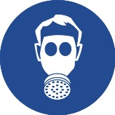

Appropriate engineering controls: Provide adequate general and local exhaust ventilation. Ensure that the direction of airflow is clearly away from the worker. Use approved respirator if air contamination is above an acceptable level. Use explosion-proof electrical, ventilating and lighting equipment. Static electricity and formation of sparks must be prevented.
Personal protection: Use the personal protective equipments showed above. Remove sources of ignition, do not
turn lights or unprotected electrical equipment on or off. In case of a major spill or spillage in a confined space evacuate the area and check that solvent vapour levels are below the Lower Explosive Limit before re-entering.
Eye/face protection: Wear tight-fitting, chemical splash goggles or face shield.
Hand protection: Use protective gloves.
Other skin and body protection: Wear appropriate clothing to prevent any possibility of liquid contact and repeated or
prolonged vapour contact.
Hygiene measures: Do not smoke in work area. Wash at the end of each work shift and before eating, smoking
and using the toilet. Promptly remove any clothing that becomes contaminated. Wash promptly with soap and water if skin becomes contaminated. Use appropriate skin cream to prevent drying of skin. Do not eat, drink or smoke when using this product.
Respiratory protection : If ventilation is inadequate, suitable respiratory protection must be worn.
Thermal hazards: No data available.
Environmental exposure controls: Keep container tightly sealed when not in use. Residues and empty containers should be taken care of as hazardous waste according to local and national provisions.

9. PHYSICAL AND CHEMICAL FEATURES

Appearance: Liquid
Odor: Characteristic
Color: Various colors
PH: Acidic
Boiling point:-
Flash Point: 26 °C (Closed cup)
Flammability (solid,gas): Not available
Explosive features:-
Oxidation features:-
Vapor pressure:Not available
Relative Density: 1,14±0,1 gr/ml

10. STABILITY AND REACTIVITY STABILITY

10.1. Reactivity
Reactivity: Stable under normal conditions
10.2. Chemical stability
Stability: Stable at normal ambient temperatures.
10.3. Possibility of hazardous reactions
Possibility of hazardous reactions: Not known.
10.4. Conditions to avoid
Conditions to avoid: Avoid heat, flames and other sources of ignition. Keep away from heat, sparks and open flame. Static electricity and formation of sparks must be prevented.
10.5. Incompatible materials
Materials to avoid: Avoid contact with the following materials: Acids - oxidising.
10.6. Hazardous decomposition products
Hazardous decomposition products: Fire creates: Toxic gases/vapours/fumes of: Carbon monoxide (CO). Carbon dioxide (CO2).

11. TOXICOLOGICAL INFORMATION

11.1. Information on toxicological effects
Acute toxicity - dermal
ATE dermal (mg/kg): 25,754.56

Acute toxicity - inhalation
ATE inhalation (vapours mg/l): 180.9
12. ECOLOGICAL INFORMATION

Ecotoxicity: The product is not expected to be dangerous for the environment.

12.1. Toxicity
There are no data available on the mixture itself.
Do not allow to enter drains or watercourses.
12.2. Persistence and degradability
Not available
12.3. Bioaccumulative potential
12.4. Mobility in soil
Not available
12.5. Results of PBT and vPvB assessment
12.6. Other adverse effects
No known signifacant effects of critical hazards.

13. DISPOSAL CONSIDERATIONS

General information: Waste should be treated as waste subject to control. As indicated by the Local Waste Disposal Authorities, it is disposed of at the licensed waste disposal site.

Disposal methods: Dispose of garbage and waste in accordance with local regulations. The containers must be empty before you throw them (risk of explosion). Throw it in the special trash bin by impregnating it to vermiculite or dry sand.

14. TRANSPORT INFORMATION

14.1. UN number
UN No. (ADR/RID): 1263
UN No. (IMDG): 1263
UN No. (ICAO): 1263
UN No. (ADN): 1263

14.2. UN proper shipping name
Proper shipping name (ADR/RID): PAINT
Proper shipping name (IMDG): PAINT
Proper shipping name (ICAO): PAINT
Proper shipping name (ADN): PAINT

14.3. Transport hazard class(es)
ADR/RID class: 3
ADR/RID classification code: F1
ADR/RID label: 3
IMDG class: 3
ICAO class/division: 3
ADN class: 3

Transport labels
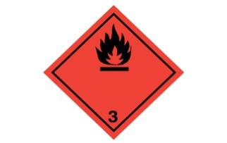

14.4. Packing group
ADR/RID packing group: III
IMDG packing group: III
ADN packing group: III
ICAO packing group: III

14.5. Environmental hazards
Environmentally hazardous substance/marine pollutant: No.

14.6. Special precautions for user
EmS: F-E, S-E
ADR transport category: 2
Emergency Action Code: •3YE
Hazard Identification Number (ADR/RID): 33
Tunnel restriction code: (D/E)

14.7. Transport in bulk according to Annex II of MARPOL and the IBC Code
Transport in bulk according to Annex II of MARPOL 73/78 and the IBC Code: Not Applicable

15. LEGISLATION INFORMATION

15.1. Safety, health and environmental regulations/legislation specific for the substance or mixture
EU legislation: According to Regulation EC no: 1272/2008

16. OTHER INFORMATIONS

General Information: This safety data sheet information was prepared as a requirement of Chemical Substances Regulations. Product 1 Chapter gives other than those specified. Utilization of the product are beyond our control to special conditions, the supplier, the consumer is responsible for ensuring that the requirements of legislation on the subject. Information consisting of present- day situation in this safety data sheet are based on national legislation, health, safety and environmental respects the way. Technical performance and does not guarantee suitability for specific situations. Based on our present knowledge projects, but they do not constitute a guarantee for any specific product features and shall not establish a legally valid contractual relationship.

Hazard statements in full

H225 Highly flammable liquid and vapour.
H226 Flammable liquid and vapour.
H304 May be fatal if swallowed and enters airways.
H312 Harmful in contact with skin.
H315 Causes skin irritation.
H317 May cause an allergic skin reaction.
H318 Causes serious eye damage.
H332 Harmful if inhaled.
H336 May cause drowsiness or dizziness.
H351 Suspected of causing cancer.
H361d Suspected of damaging the unborn child.
H373 May cause damage to organs through prolonged or repeated exposure.

This information relates only to the specific material designated and may not be valid for such material used in combination
with any other materials or in any process. Such information is, to the best of the company's knowledge and belief, accurate
and reliable as of the date indicated. However, no warranty, guarantee or representation is made to its accuracy, reliability or
completeness. It is the user's responsibility to satisfy himself as to the suitability of such information for his own particular use.

