It has been prepared in accordance with the Regulation (EC) No 1272/2008
1. IDENTIFICATION OF THE MATERIAL/PREPARATION AND COMPANY/OWNER
1.1.Product Identifier
Material/Preparation Name and Code: Yalaz Solvent-Free Epoxy Paint
Preparation Date: 01/09/2008

1.2 Relevant identified uses of the substance or mixture and uses advised against.
Use of the Material / Preparation: Solvent-free epoxy resin based two component paint.

1.3. Details of the supplier of the safety data sheet
Supplier: Yalaz Boya Kim.Ve Gida Ürn.İth.İhr.San.Tic.Ltd.Şti
Yazıbaşı Torbalı İZMİR
www.yalazboya.com.tr
1.4.Emergency Phone: 02324792635

2. HAZARDS IDENTIFICATION

2.1. Classification of the substance or mixture
Classification (EC 1272/2008)

Physical hazards:Not classified.

Health hazards: Skin Irrit. 2 - H315 Eye Irrit. 2 - H319 Skin Sens. 1 - H317
Environmental hazards: Aquatic Chronic 2 - H411

2.2. Label elements
Pictogram

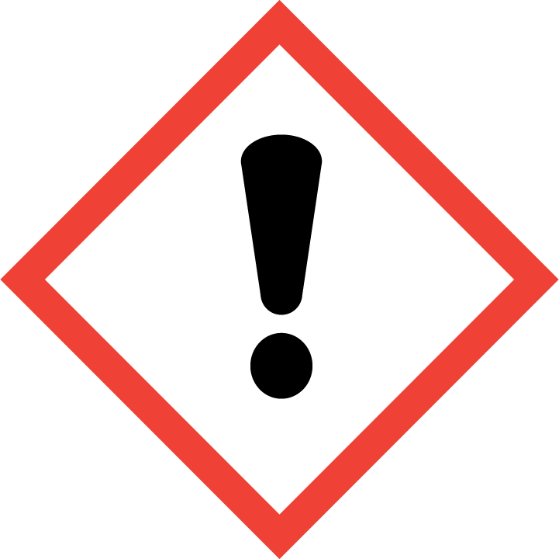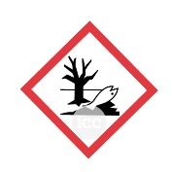

Signal Word :Warning

Hazar Statements:

H315 Causes skin irritation.
H317 May cause an allergic skin reaction.
H319 Causes serious eye irritation.
H411 Toxic to aquatic life with long lasting effects

Precautionary statements:

P261 Avoid breathing vapour/ spray.
P264 Wash contaminated skin thoroughly after handling.
P272 Contaminated work clothing should not be allowed out of the workplace.
P273 Avoid release to the environment.
P280 Wear protective gloves/ protective clothing/ eye protection/ face protection.
P302+P352 IF ON SKIN: Wash with plenty of water.
P305+P351+P338 IF IN EYES: Rinse cautiously with water for several minutes. Remove
contact lenses, if present and easy to do. Continue rinsing.
P321 Specific treatment (see medical advice on this label).
P332+P313 If skin irritation occurs: Get medical advice/ attention.
P333+P313 If skin irritation or rash occurs: Get medical advice/ attention.
P337+P313 If eye irritation persists: Get medical advice/ attention.
P362+P364 Take off contaminated clothing and wash it before reuse.
P391 Collect spillage.
P501 Dispose of contents/ container in accordance with national regulations.

Contains:Epoxy esin

3. COMPOSITION/INFORMATION ON INGREDIENTS

Name | EC No. | CAS No | Ingredients % | Classification (T.R.27092 )  (67/548/EEC)
Epoxy resin |  |  | 25-50% | Skin Irrit. 2 - H315  Eye Irrit. 2 - H319  Skin Sens. 1 - H317  Aquatic Chronic 2 - H411
Dıstıllates (Petroleum), Hydrotreated Lıght;  Kerosıne - Unspecıfıed | 265-149-8 | 64742-47-8 | 1-5% | Asp. Tox. 1 - H304

The full text for all hazard statements is displayed in Section 16.
4. FIRST AID MEASURES

4.1. Description of first aid measures
General information :In all cases of doubt, or when symptoms persist, seek medical attention. Never give anything
by mouth to an unconcious person. Show this label or product container to the medically
authorized person.
Inhalation:Move affected person to fresh air at once. Get medical attention.
Ingestion: DO NOT induce vomiting. Get medical attention immediately. If vomiting occurs, the head
should be kept low so that vomit does not enter the lungs.
Skin contact :Remove contaminated clothing. Wash skin thoroughly with soap and water. Get medical
attention immediately.
Eye contact: Remove any contact lenses and open eyelids wide apart. Continue to rinse for at least 15
minutes and get medical attention.
Protection of first aiders :First aid personnel should wear appropriate protective equipment during any rescue.
4.2. Most important symptoms and effects, both acute and delayed
General information:In all cases of doubt, or when symptoms persist, seek medical attention. Never give anything
by mouth to an unconscious person.
Inhalation :Harmful if inhaled.
Ingestion: May be fatal if swallowed and enters airways.
Skin contact,: Causes skin irritation.
Eye contact: Irritation, burning, lachrymation, blurred vision after liquid splash. May cause serious eye
damage.
4.3. Indication of any immediate medical attention and special treatment needed
Notes for the doctor: Treat symptomatically

5. FIRE FIGHTING MEASURES

5.1. Extinguishing media
Suitable extinguishing media: Use fire-extinguishing media suitable for the surrounding fire. Extinguish with alcohol-resistant foam, carbon dioxide or dry powder.
Unsuitable extinguishing media: Water.
5.2. Special hazards arising from the substance or mixture
Specific hazards: Not known.
Hazardous combustion products: Oxides of carbon.
5.3. Advice for firefighters
Protective actions during firefighting: Contain and collect extinguishing water.
Special protective equipment for firefighters:Wear chemical protective suit. Use air-supplied respirator, gloves and protective goggles.

6. ACCIDENTAL RELEASE MEASURES

6.1. Personal precautions, protective equipment and emergency procedures
Personal precautions: Wear protective clothing as described in Section 8 of this safety data sheet. Avoid inhalation
of vapours and contact with skin and eyes.
For non-emergency personnel: No data available.
For emergency responders: No data available.
6.2. Environmental precautions
Environmental precautions: Avoid or minimise the creation of any environmental contamination. Contain spillage with
sand, earth or other suitable non-combustible material.
6.3. Methods and material for containment and cleaning up
Methods for cleaning up:Wear suitable protective equipment, including gloves, goggles/face shield, respirator, boots,
clothing or apron, as appropriate. Absorb in vermiculite, dry sand or earth and place into
containers. Avoid the spillage or runoff entering drains, sewers or watercourses.
6.4. Reference to other sections
Reference to other sections:For personal protection, see Section 8. The product contains a substance which is hazardous
to aquatic organisms and which may cause long term adverse effects in the aquatic
environment. See Section 12 for additional information on ecological hazards.

7. HANDLING AND STORAGE

7.1. Precautions for safe handling
Usage precautions: Avoid spilling. Provide adequate ventilation. Avoid inhalation of vapours. Use approved
respirator if air contamination is above an acceptable level. Wear eye and face protection.Wear appropriate clothing to prevent any possibility of skin contact.
Advice on general occupational hygiene: When using do not eat, drink or smoke. Do not smoke in work area. Eye wash facilities and emergency shower must be available when handling this product. Good personal hygiene procedures should be implemented. Wash promptly if skin becomes contaminated. Promptly remove any clothing that becomes wet or contaminated.
7.2. Conditions for safe storage, including any incompatibilities
Storage precautions: Store in tightly-closed, original container in a dry, cool and well-ventilated place.
Storage class: Flammable liquid storage.
7.3. Specific end use(s)
Usage description: Use the product according to its Technical Data Sheet or instructions written on the label

8. EXPOSURE CONTROLS/PERSONAL PROTECTION

8.1. Control parameters
Ingredient comments
WEL = Workplace Exposure Limits
8.2. Exposure controls
Protective equipment
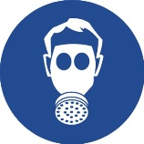

Appropriate engineering controls: Provide adequate general and local exhaust ventilation. Ensure that the direction of airflow is clearly away from the worker. Use approved respirator if air contamination is above an acceptable level. Use explosion-proof electrical, ventilating and lighting equipment. Static electricity and formation of sparks must be prevented.
Personal protection: Use the personal protective equipments showed above. Remove sources of ignition, do not
turn lights or unprotected electrical equipment on or off. In case of a major spill or spillage in a confined space evacuate the area and check that solvent vapour levels are below the Lower Explosive Limit before re-entering.
Eye/face protection: Wear tight-fitting, chemical splash goggles or face shield.
Hand protection: Use protective gloves.
Other skin and body protection: Wear appropriate clothing to prevent any possibility of liquid contact and repeated or
prolonged vapour contact.
Hygiene measures: Do not smoke in work area. Wash at the end of each work shift and before eating, smoking
and using the toilet. Promptly remove any clothing that becomes contaminated. Wash promptly with soap and water if skin becomes contaminated. Use appropriate skin cream to prevent drying of skin. Do not eat, drink or smoke when using this product.
Respiratory protection : If ventilation is inadequate, suitable respiratory protection must be worn.
Thermal hazards: No data available.
Environmental exposure controls: Keep container tightly sealed when not in use. Residues and empty containers should be taken care of as hazardous waste according to local and national provisions.

9. PHYSICAL AND CHEMICAL FEATURES

Appearance: Liquid
Color: Clear liquid
Flash Point: 102°C

10. STABILITY AND REACTIVITY STABILITY

10.1. Reactivity
Reactivity: Stable under normal conditions
10.2. Chemical stability
Stability: Stable at normal ambient temperatures.
10.3. Possibility of hazardous reactions
Possibility of hazardous reactions: Not known.
10.4. Conditions to avoid
Conditions to avoid: Avoid heat, flames and other sources of ignition. Keep away from heat, sparks and open flame. Static electricity and formation of sparks must be prevented.
10.5. Incompatible materials
Materials to avoid: Avoid contact with the following materials: Acids - oxidising.
10.6. Hazardous decomposition products
Hazardous decomposition products: Fire creates: Toxic gases/vapours/fumes of: Carbon monoxide (CO). Carbon dioxide (CO2).

11. TOXICOLOGICAL INFORMATION

11.1. Information on toxicological effects
Toxicological effects
No information available.
Inhalation
Irritating to respiratory system.
Ingestion
Toxic if swallowed.
Skin contact
May cause sensitisation by skin contact.
Eye contact
Irritating to eyes
12. ECOLOGICAL INFORMATION

Ecotoxicity: Toxic to aquatic life with long lasting effects.
12.1. Toxicity
Acute toxicity - fish
LC₅₀, 96 hours: 1-10 mg/l, Algae
12.2. Persistence and degradability
Persistence and degradability
Not expected to be readily biodegradable.
12.3. Bioaccumulative potential
Bioaccumulative potential
No data available on bioaccumulation.
12.4. Mobility in soil
12.5. Results of PBT and vPvB assessment
12.6. Other adverse effects
Other adverse effects
Not known.

13. DISPOSAL CONSIDERATIONS

General information: Waste should be treated as waste subject to control. As indicated by the Local Waste Disposal Authorities, it is disposed of at the licensed waste disposal site.

Disposal methods: Dispose of garbage and waste in accordance with local regulations. The containers must be empty before you throw them (risk of explosion). Throw it in the special trash bin by impregnating it to vermiculite or dry sand.

14. TRANSPORT INFORMATION

14.1. UN number
UN No. (ADR/RID): 3082
UN No. (IMDG): 3082
UN No. (ICAO): 3082
UN No. (ADN): 3082

14.2. UN proper shipping name
Proper shipping name (ADR/RID): ENVIRONMENTALLY HAZARDOUS SUBSTANCE, LIQUID, N.O.S. (CONTAINS
MAREPOKS 1721, stoddard solvent, (nota p))
Proper shipping name (IMDG): ENVIRONMENTALLY HAZARDOUS SUBSTANCE, LIQUID, N.O.S. (CONTAINS
MAREPOKS 1721, stoddard solvent, (nota p))
Proper shipping name (ICAO): ENVIRONMENTALLY HAZARDOUS SUBSTANCE, LIQUID, N.O.S. (CONTAINS
MAREPOKS 1721, stoddard solvent, (nota p))
Proper shipping name (ADN): ENVIRONMENTALLY HAZARDOUS SUBSTANCE, LIQUID, N.O.S. (CONTAINS
MAREPOKS 1721, stoddard solvent, (nota p))

14.3. Transport hazard class(es)
ADR/RID class: 9
ADR/RID classification code: M6
ADR/RID label: 9
IMDG class: 9
ICAO class/division: 9
ADN class: 9

Transport labels
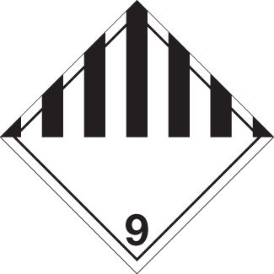

14.4. Packing group
ADR/RID packing group: III
IMDG packing group: III
ADN packing group: III
ICAO packing group: III

14.5. Environmental hazards
Environmentally hazardous substance/marine pollutant
14.6. Special precautions for user
EmS: F-A, S-F
ADR transport category: 3
Hazard Identification Number (ADR/RID): 90
Tunnel restriction code: (E)

14.7. Transport in bulk according to Annex II of MARPOL and the IBC Code
Transport in bulk according to Annex II of MARPOL 73/78 and the IBC Code: Not Applicable

15. LEGISLATION INFORMATION

15.1. Safety, health and environmental regulations/legislation specific for the substance or mixture
EU legislation: According to Regulation EC no: 1272/2008

16. OTHER INFORMATIONS

General Information: This safety data sheet information was prepared as a requirement of Chemical Substances Regulations. Product 1 Chapter gives other than those specified. Utilization of the product are beyond our control to special conditions, the supplier, the consumer is responsible for ensuring that the requirements of legislation on the subject. Information consisting of present- day situation in this safety data sheet are based on national legislation, health, safety and environmental respects the way. Technical performance and does not guarantee suitability for specific situations. Based on our present knowledge projects, but they do not constitute a guarantee for any specific product features and shall not establish a legally valid contractual relationship.

Hazard statements in full

H304 May be fatal if swallowed and enters airways.
H315 Causes skin irritation.
H317 May cause an allergic skin reaction.
H319 Causes serious eye irritation.
H411 Toxic to aquatic life with long lasting effects.

This information relates only to the specific material designated and may not be valid for such material used in combination
with any other materials or in any process. Such information is, to the best of the company's knowledge and belief, accurate
and reliable as of the date indicated. However, no warranty, guarantee or representation is made to its accuracy, reliability or
completeness. It is the user's responsibility to satisfy himself as to the suitability of such information for his own particular use.

