СТОК 4 | Женская одежда |  | Брюки для подростков
Мин.кол. / шт | 23 | Бренд | Sexy Woman (Einstein) - Италия
В наличии/шт | 260 | Сезон | осень/зима
Цена €/шт | 3 | Состояние | фабричный сток в упаковке
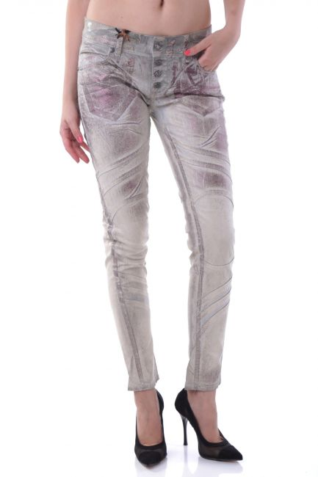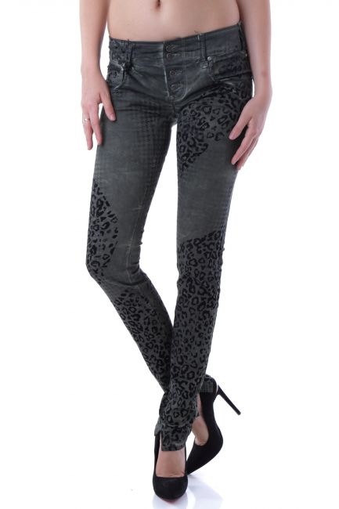
J1925 – XXS J1966 – XXS, XS

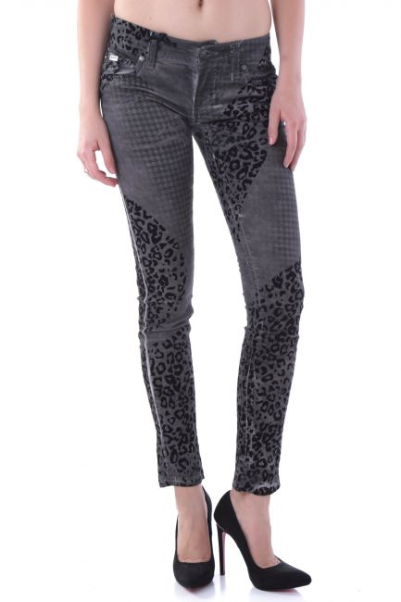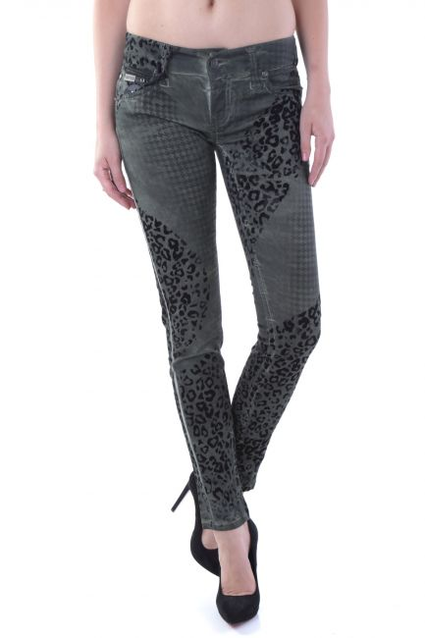
J1972A – XXS J1972B – XXS, XS

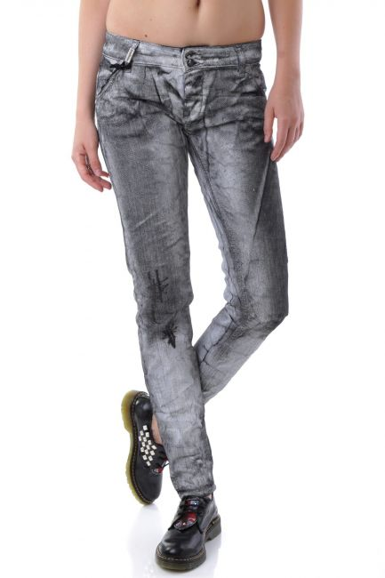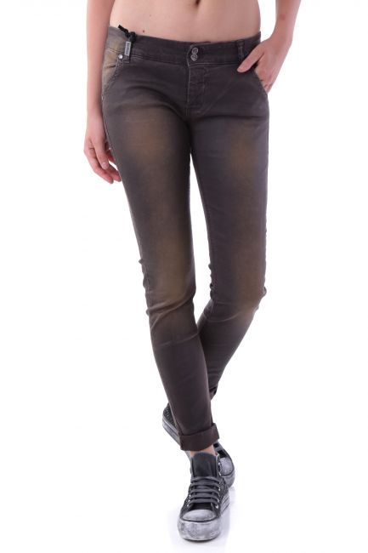
J1975 – XXS J1978 – XXS, XS

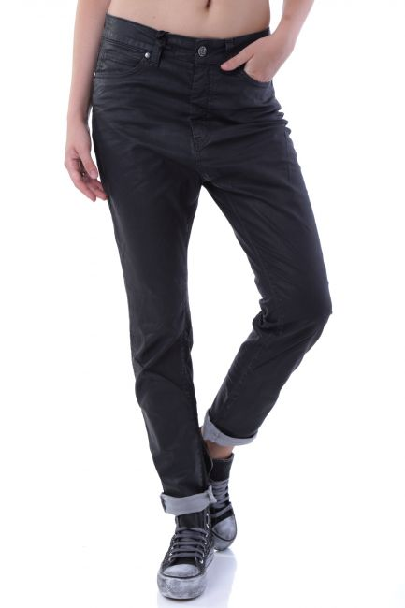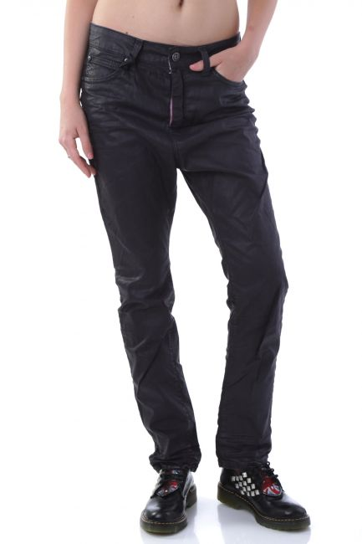
J1980A – XXS J1980B – XXS, XS

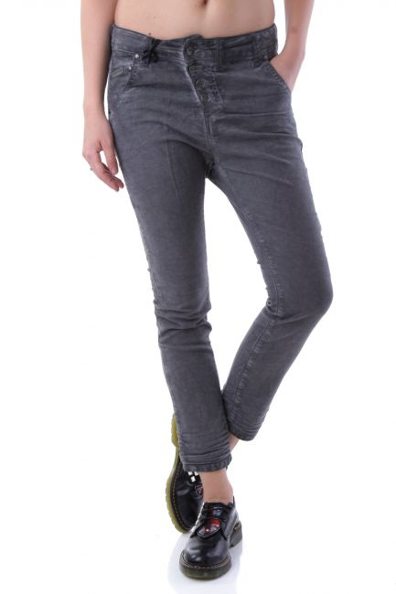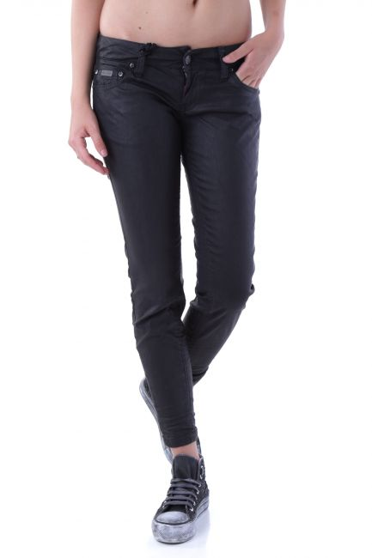
J1998 – XXS J2032 – XXS, XS

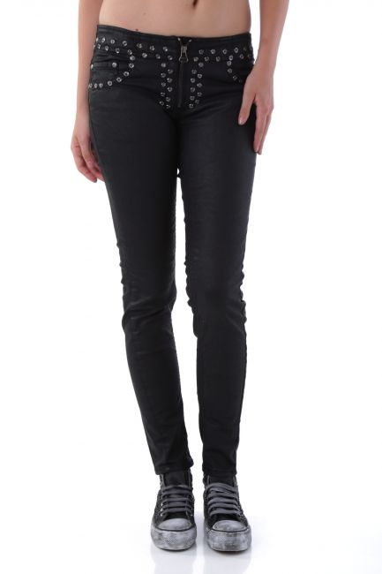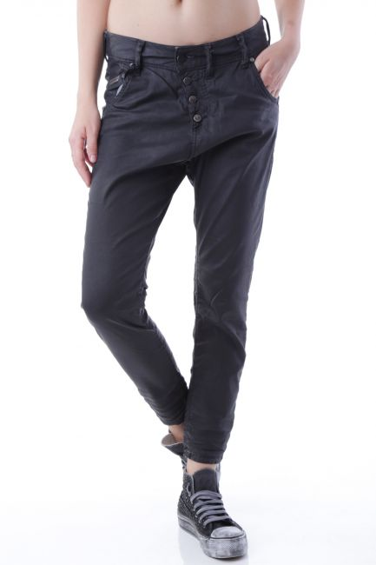
J2041 – XXS J2043 – XXS, XS

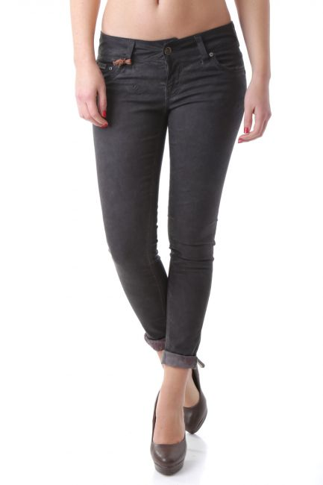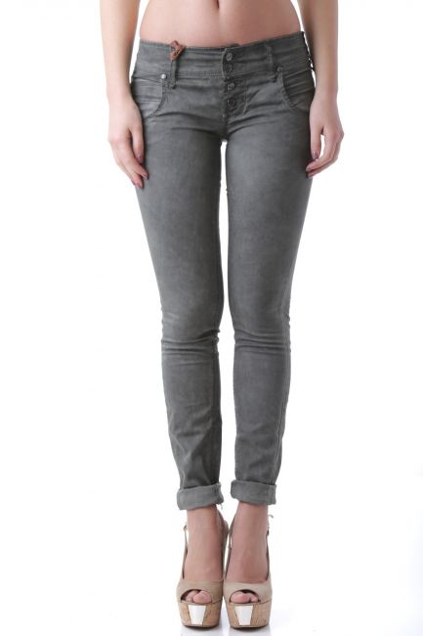
J2300 – XXS, XS J2304 – XS

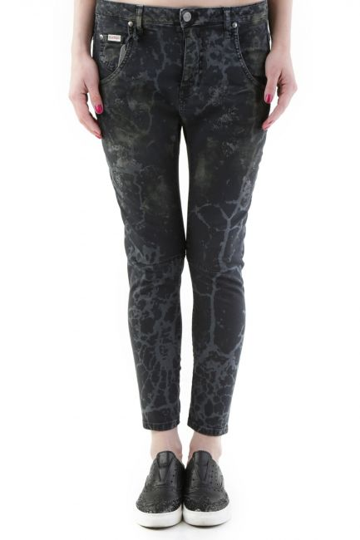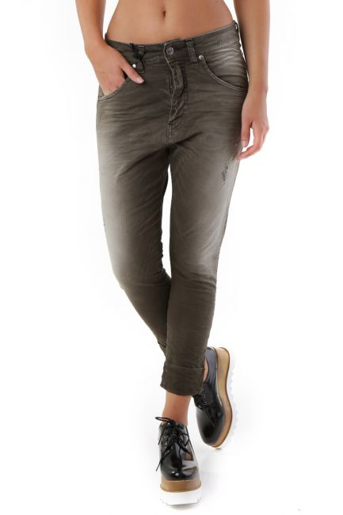

J2846 – XXS J2911 – XS

