|  |  |  |  |
| --- | --- | --- | --- |
| **СТОК 5** | Женская одежда | | **Джинсы/брюки для подростков** |
| Мин.кол. / шт | **50** | Бренд | Sexy Woman (Einstein) - Италия |
| В наличии/шт | 740 | Сезон | осень/зима |
| Цена €/шт | **5** | Состояние | фабричный сток в упаковке |

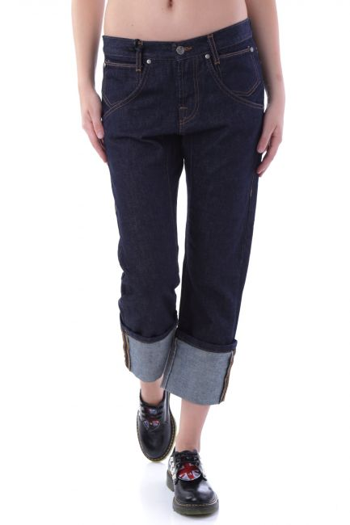 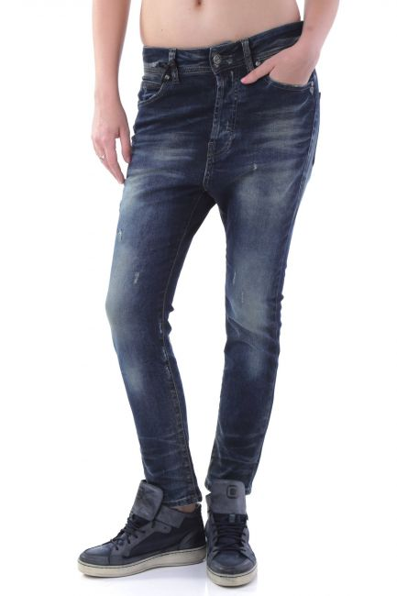

**J1926 – XXS, XS J1967 – XXS, XS**

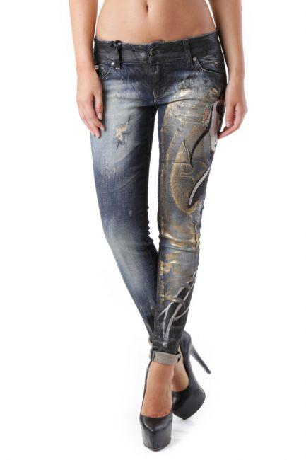 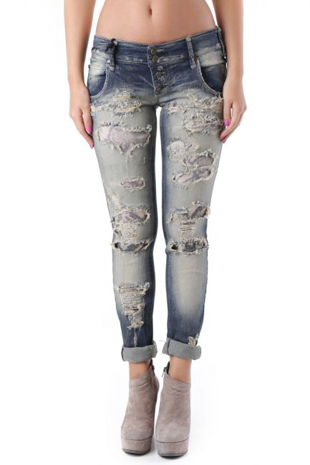

**J2677 – XS J2678 – XS**

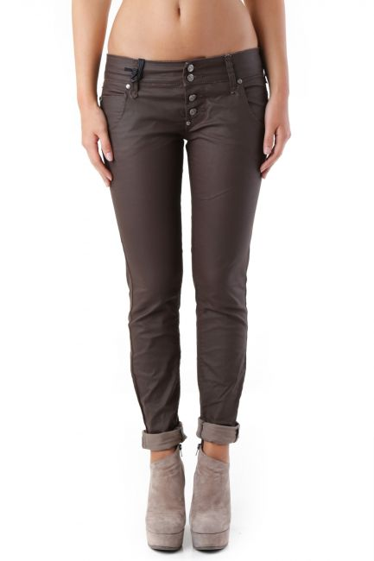 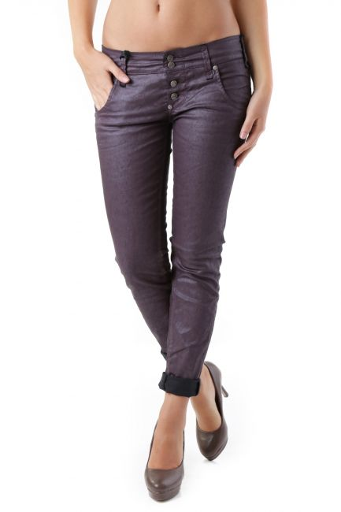

**J2686 – XXS** **J2689 – XXS, XS**

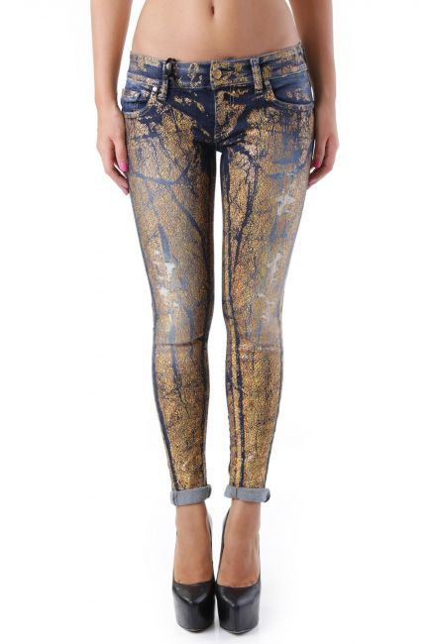 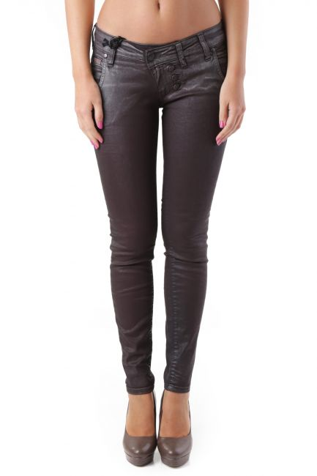

**J2697 – XXS, XS** **J2719 – XS**

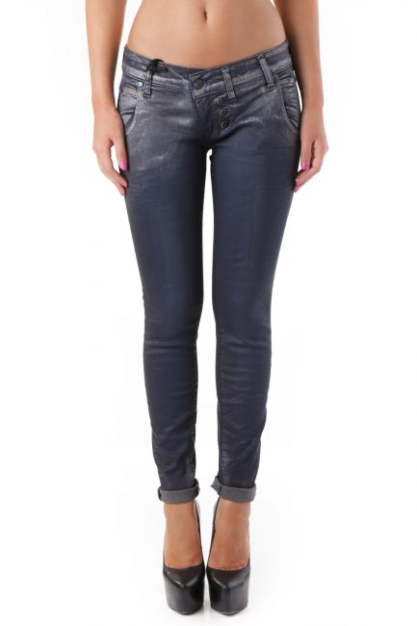 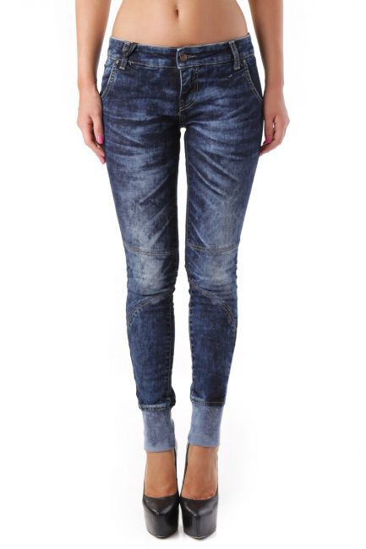

**J2719A – XXS, XS J2723 – XS**

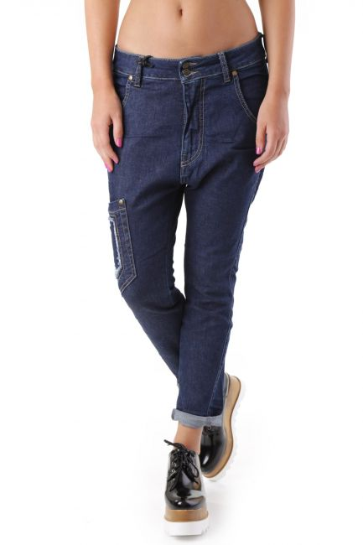 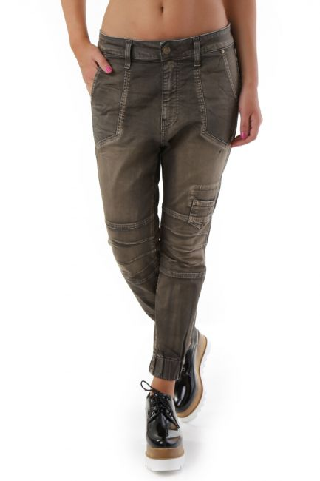

**J2724 – XXS, XS J2737 – XXS**

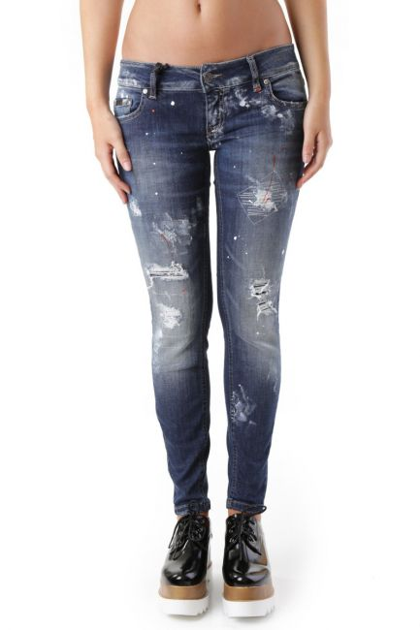 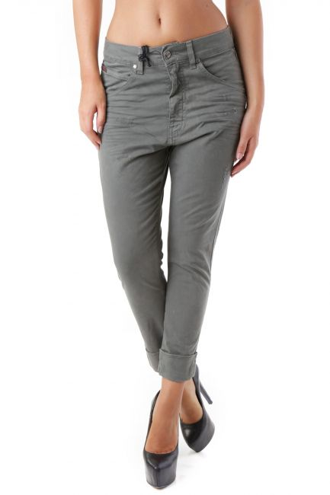

**J2745 – XS J2898 – XXS, XS**

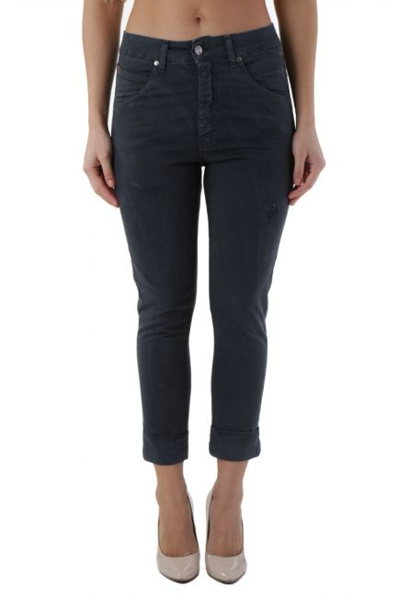 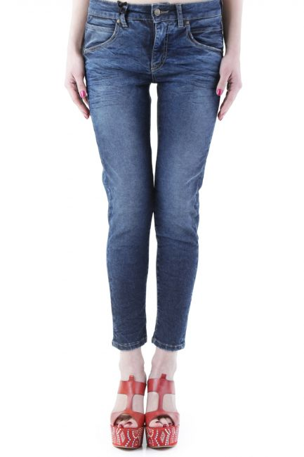

**J2898B – XXS, XS J2978 – XS**

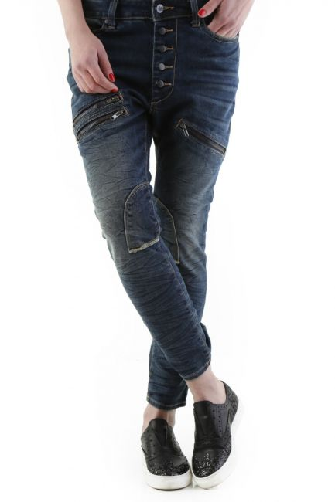 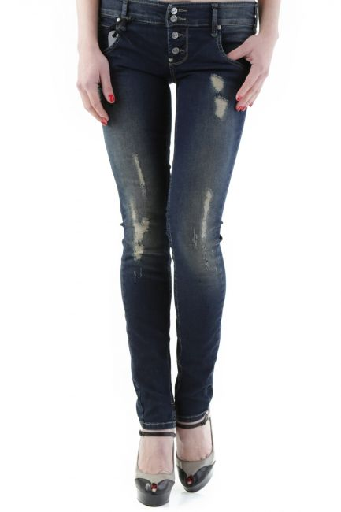

**J2980 – XXS**  **J2990 – XS**

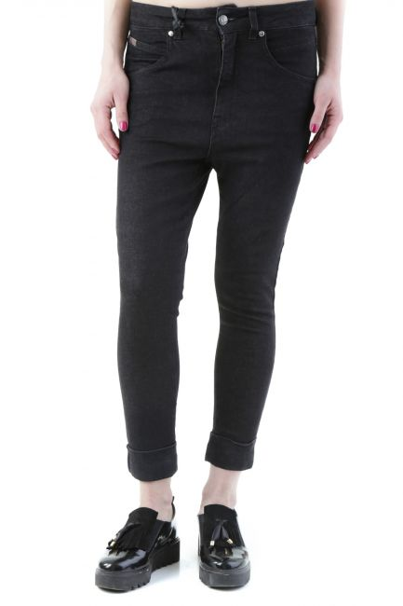 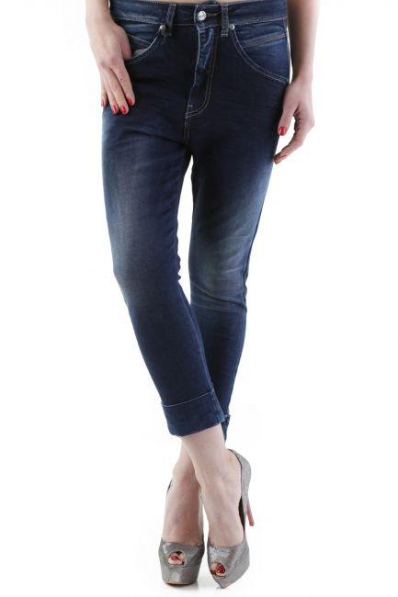

**J2992 – XS J2996 – XXS**

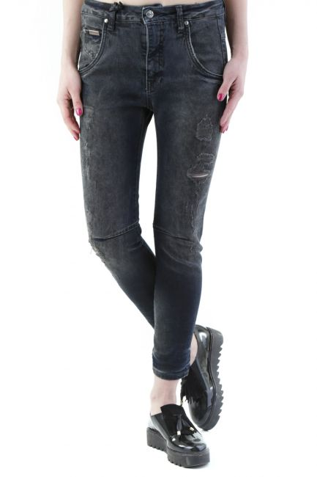 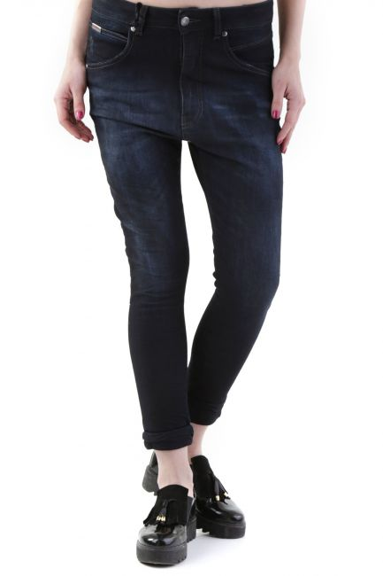

**J3049 – XXS,XS**  **J3066 – XXS,XS**

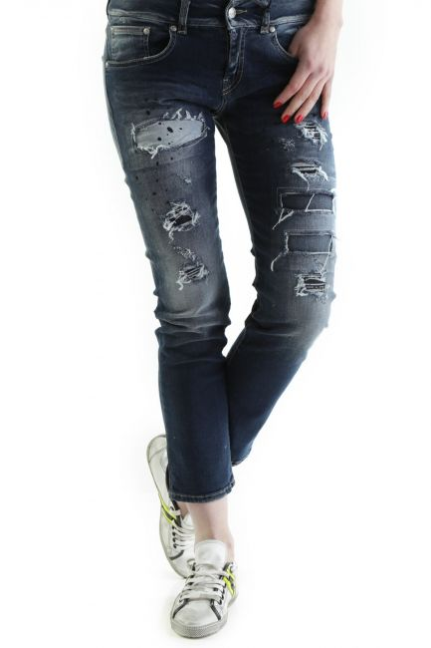 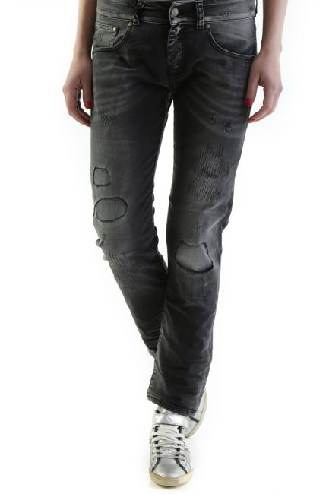

**J3071 – XXS,XS**  **J3073 – XXS,XS**

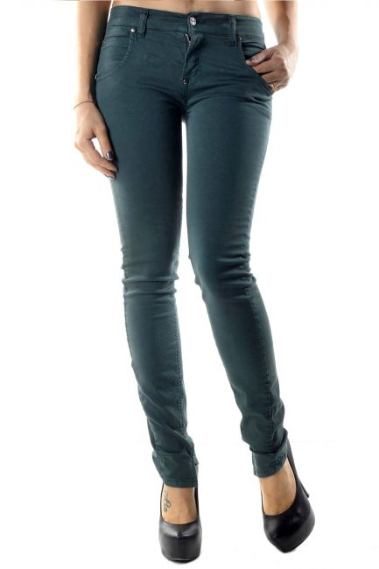 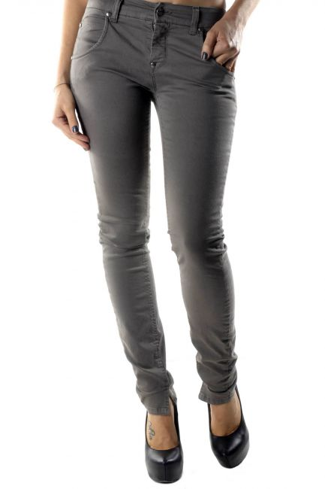

**J3328A – XS**  **J3328B – XXS, XS**

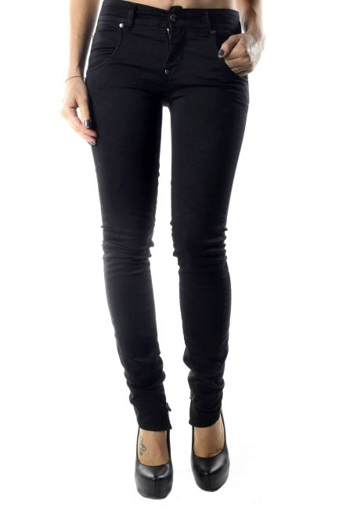 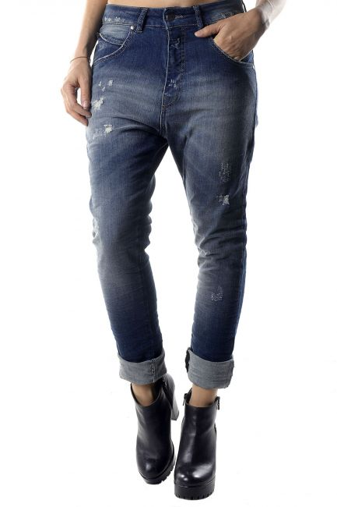

**J3328C – XS J3329 – XXS, XS**

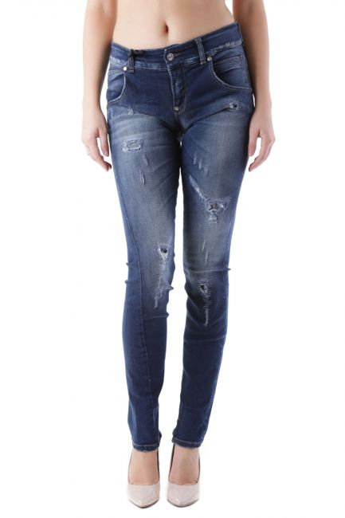 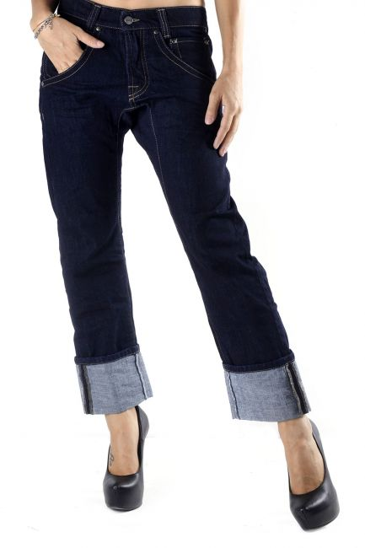

**J3334A – XS**  **J3336A – XS**

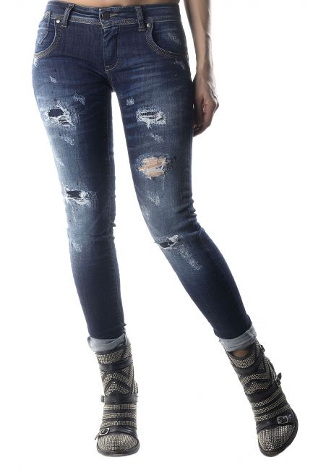 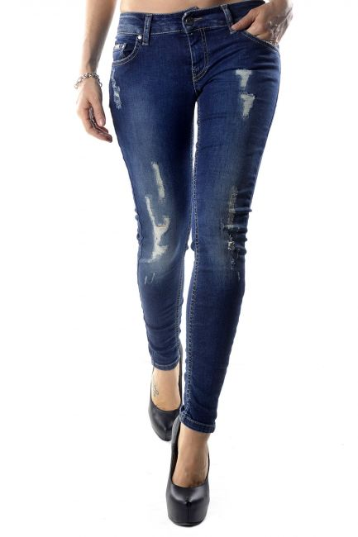

**J3337A – XS**  **J3338A – XS**

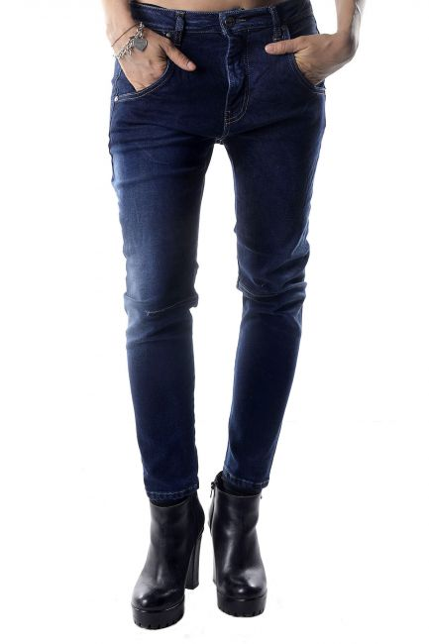 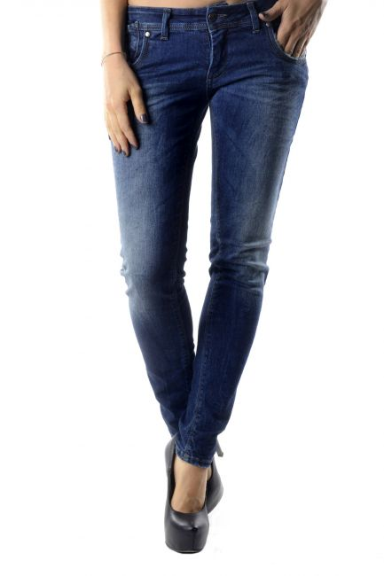

**J3346A – XXS**  **J3352A – XS**

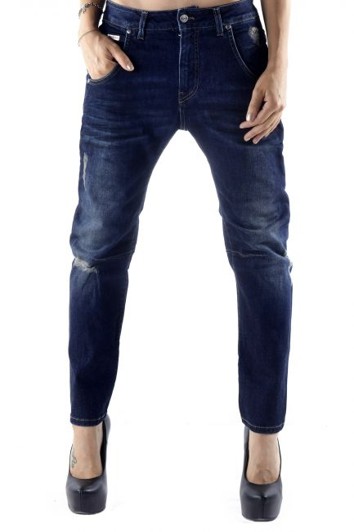 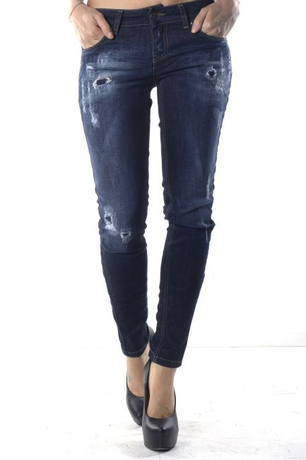

**J3353A – XS J3354A – XS**